WEEK 2 ASSESSMENT

**CSS & VANILLA JAVASCRIPT**

# IN YOUR TEXT FILE, WRITE THE CODE TO COMPLETE THE FOLLOWING

1. There are 4 ways to specify color value in CSS. List at least 3 of them and give examples of their use.
2. There are a few ways to specify units of measure in CSS. List at least 3 of them and give examples of their use
3. If an element was 100px wide with a padding of 5px and border of 5px – what is the total width of the element?
4. Declare a variable called truth and initialize it to the string “Dogs are the best”
5. What are the six datatypes in JavaScript?
6. There are several falsy values in JavaScript. Name three.
7. Create a for loop that logs the integers from 9 to 33 to the console (including 33).
8. Declare a variable called teamJavaScript, initialize it as an array of strings with the values “Adam”, “Anna”, “David”, and “Grant”. Use the forEach method to log each element of the array to the console
9. Assume an array named treats. Write the code that will add the string “Cookies” to the end of that array.

Continued on back...

1. Consider the following code, what will be printed to the console? In a few sentences, explain why.

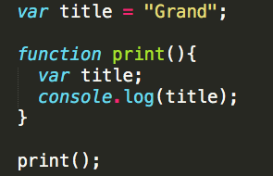

1. Consider the following code, what will be printed to the console? In a few sentences, explain why

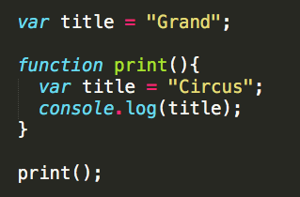

1. Declare a variable phoneBook, initialize it as an array of objects. Each object should have properties of name and accountNumber. Add an object for each of these places:

Name: “Grant Chirpus”

Number: 3133382780

Name: “Taylor Swift”

Number: 1234567890

Name: “Rocky Balboa”

Number: 1238675309

Name: “Indiana Jones”

Number: 5555555555